]]][[po

| Name: | ID: | Section: |
| --- | --- | --- |

**Problem Set 2 (Diodes and Method of Assumed States)**

**BRAC University**

Semester: Spring 2024

| Course No.: CSE251 |
| --- |
| Course title: Electronic Devices and Circuits |

**Diodes:**

Diode is a two terminal semiconductor device that acts as a one way valve for electric currents. 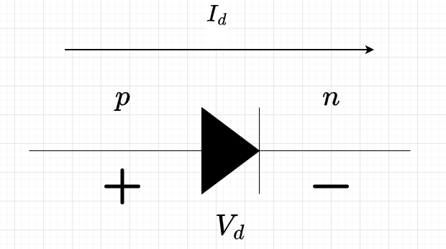

It is also called a pn junction diode because it is formed with p-type and n-type semiconductors kept adjacent to each other.

We won’t deal with the physics of the pn junction for now [reading material will be provided for those interested], we’ll only be interested in the terminal characteristics of the diode, namely it’s IV-characteristics.

A very accurate current voltage relationship (or, IV relationship) for the diode is given by the Schockley Equation:

**Id = Is [exp ()-1]**

Here,

**Id** = The current through the diode

**Vd** = The voltage across the diode [measured from the p-side, or the flat side of the triangle]

The other terms are constants that depend on the way the component was built and/or the ambience of the surroundings:

**Is** = reverse saturation current, usually assumed to be **10-12 A**, device dependant

**VT** = defined as thermal voltage, around **25.9 mV** at room temperature. Dependant on the temperature of the surroundings

**n** = a device parameter we won’t be too concerned about! We will assume **n = 1**

This is a nonlinear IV relationship, something that’ll be a problem for us since we’ve only learned linear circuit solving techniques!

If we don’t worry too much about Is, VT and n, our IV relation is simply an exponential function of diode terminal voltage:

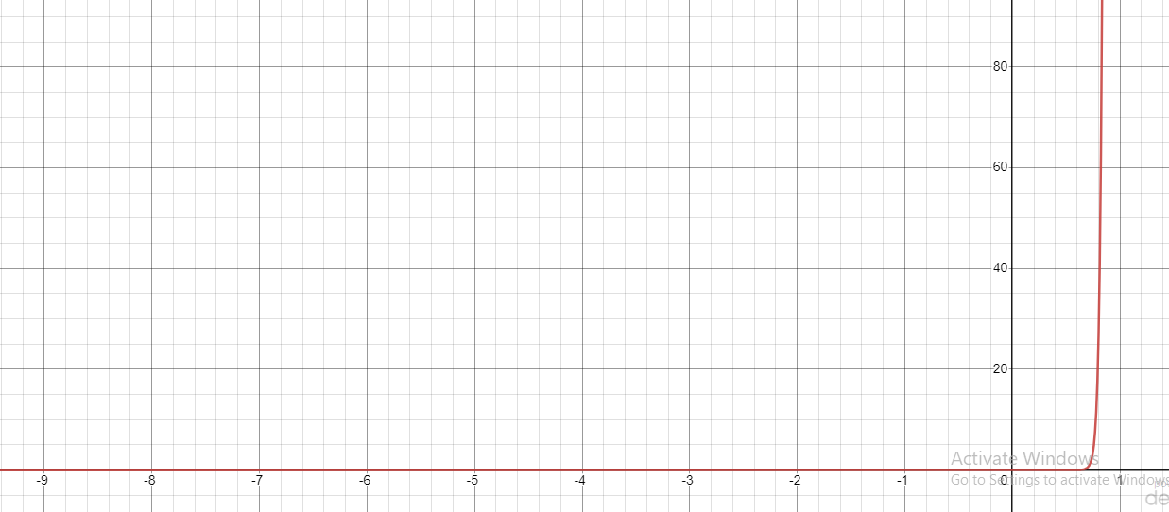

We can also make the voltage of the diode the subject and form an expression in terms of the diode current, Id:

**Vd = VT ln [ + 1]**

Now, we have two expressions, one for the diode current and one for the diode voltage.

1. **(CO1: 0.5 x 9 = 4.5)** Given, some specific values of diode current, Id, find the value of the diode terminal voltage, Vd with the above expression:

1 uA, 1mA, 10 mA, 50 mA, 1 A, 5 A, 10 A, 103 A, 106 A

1. **(CO1: 0.5 x 11 = 5.5)** Given, some specific values of diode terminal voltage, Vd , find the value of the diode current, Id with the Schockley equation:

-50 V, -10 V, -1 V, 0 V, 0.1 V, 0.5 V, 0.7 V, 0.8 V, 0.9 V, 1 V, 2 V

From the calculations above, you’ll notice that no matter how high of a positive current the diode allows it to flow through, the voltage drop is relatively small, around the range of 0.5 – 1.1 V.

At the same time, we notice that in order to achieve anything beyond 1 V across the diode terminals requires a tremendous amount of current (~around the order of 106). In our simple electronic circuits, we usually deal with currents in the milliampere range (10-3 A)!

For simplifying the analysis and to avoid having to deal with nonlinear equations, we approximate the diode to consist of two states.

**Constant Voltage Drop (CVD) Model:**

In this approximate model of the diode, we assume that it can take TWO states: i) ON state and ii) OFF state

1. When the diode is ON (or forward biased), we say it has the following properties: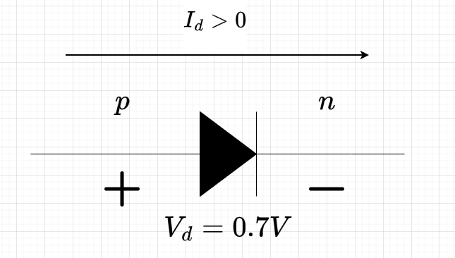

* The diode current is flowing from the p side to the n side, i.e, the current is positive **(Id > 0)**
* The terminal voltage drop across the diode is assumed to be 0.7 V. **(Vd = 0.7 V)**

We can replace this diode with an equivalent model as follows:

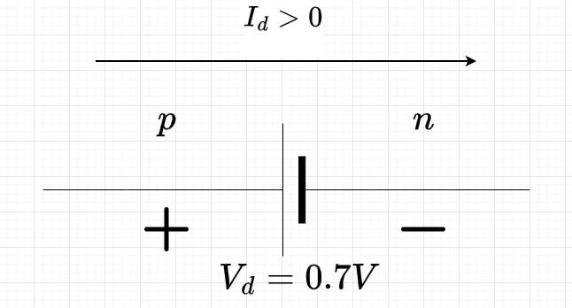

This equivalent diode circuit will be used if any of the following two conditions are fulfilled in a circuit.

Here, the diode will be a kind of voltage obstructor (since the current flows towards the positive end). It will eat away around 0.7V from the circuit all the time. We will see examples in the upcoming sections how that works

1. When the diode if OFF (or reverse biased), we say it has the following properties: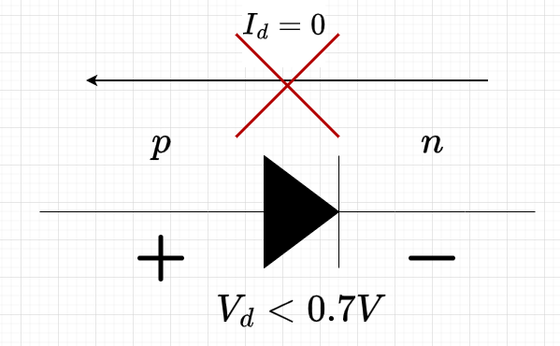

* The diode current tries to flow from the n side to the p side but it cannot do so, hence the current is zero **(Id = 0)**
* The voltage across the diode is less than 0.7 V (usually a negative voltage) **(Vd < 0.7 V)**

We can replace the diode model with an equivalent circuit as follows:

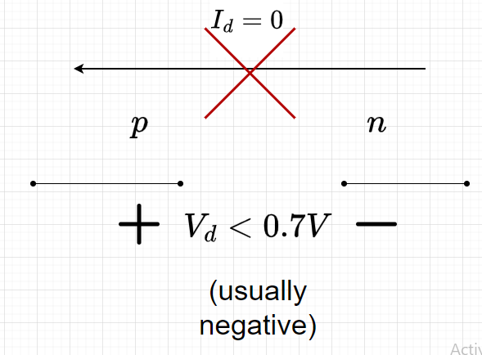

This equivalent circuit will be used if any of the two conditions above are met.

Here, the diode acts as an open circuit component and current cannot flow through it. **(Id = 0)**

Using this two state model of the diode to solve circuits is much simpler than using the Schockley equation! How will we do this? Let us first state the rules we apply when solving such a circuit:

1. When analyzing diode circuits, we assume any one of these TWO states of the diode and solve the circuit.
2. Then we solve the circuit and observe the voltage and current across the diode.
3. If it is meeting the conditions above for the assumed state, the circuit solving is complete and our answer is correct if we have not made any human errors.
4. If it is not meeting the conditions above, we say that our assumption is false. And we make a different assumption for the diode and repeat from step 1.

This is known as the Method of Assumed States (MAS) and is used to extensively solve circuits with such piecewise models.

Let us take a simple example to understand the concept better:

Example 1:

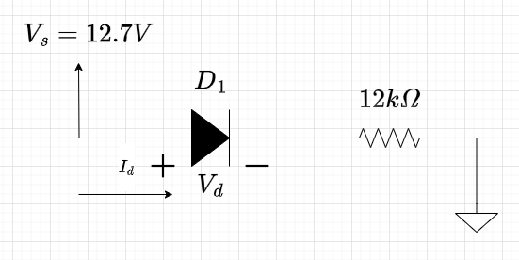

Let us solve the circuit above. First we make an assumption about our diode, D1. Let us assume that D1 is OFF. Then the circuit becomes:

Since the circuit is open, no current flows through the circuit, so Id = 0.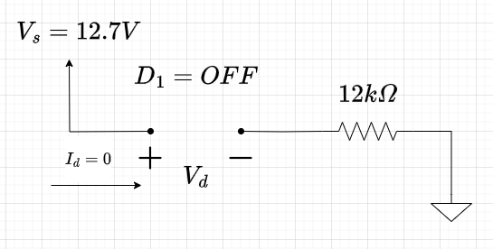

Also, since IR = 0, so the voltage on two ends of the resistor is the same. So, the left side voltage = right side voltage = 0 V

Therefore, voltage across D1 = Vs – 0 = 12.7 – 0 = 12.7 V

If D1 is to be OFF, then:

* Must have no current through it
* Vd < 0.7 V.

Clearly, we have a contradiction since Vd = 12.7 V > 0.7 V. Then, our assumption is false! Let us now assume D1 is ON:

Then the circuit becomes:

We notice that the replaced voltage source for the diode does not contribute to the flow of current, but rather acts as an obstructor of voltage!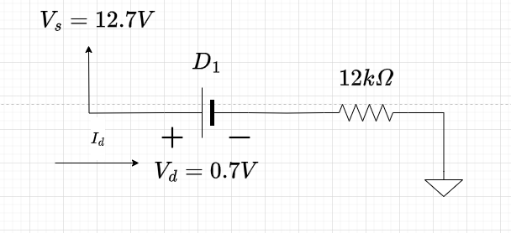

If we write the KVL line equation, we get:

0.7 + 12I = 12.7 – 0

Or, I = (12.7-0.7)/12

Or, I = 1 mA

Let us now check the diode voltage and current and verify its state:

* Id = 1 mA > 0 [condition one satisfied for ON state]
* Vd = 0.7 V [condition two satisfied for ON state]

Thus, the diode conditions are met. So, we can safely say that there is no contradiction and our circuit solving is successful!

Making any arbitrary assumption and then trying to see if we can get a contradiction is a rather time-consuming process. It would be extremely helpful if we could guess the operating state of the diodes as accurately as possible during our first try!

And that is possible in some instances! Suppose for example, in the above example:

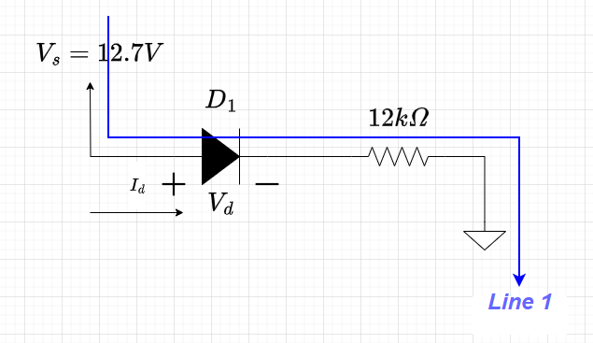

Observe how the voltage source, Vs is trying to force current towards the ground terminal. In general, in a circuit, the higher potential will try to push current towards the lower voltage node.   
This is especially easy to understand in simple lines like the above circuit. You have a source that is trying to push current towards ground.

You can compare this phenomenon to that of a water pump trying to pump water from a high potential to a low potential.

The blue arrow is the intended current direction that the source is trying to push for. Making it so that current flows in that direction

With these observations, can we conclude that a positive current flows through the diode positive end or the p side? Indeed, since current Id should be positive in that case.

Thus, logically, we should have that the diode is in its ON state.

Notice how we came to this conclusion without having to exhaustively go through the OFF state beforehand.

Obviously, we always cannot make the right assumption even if it may seem intuitive to us. Even so, even getting a few assumptions correct with such deductions can make our life simpler. All we have to do after that is verify our diode states.

***[There are many more diode solved problems attached in your sections drive, in the diode_spring.pdf, Method_of_Assumed_states_examples.pdf, and assumed_states.pdf]***

**3)** **(CO2: 3 x 4 = 12)** Using the CVD model of the diode, solve the following diode circuits and find the specified voltages/currents as well as the current through the diodes and voltage across the diodes: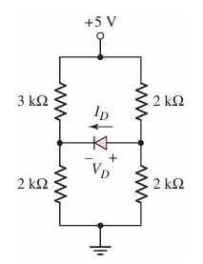

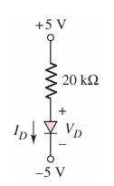

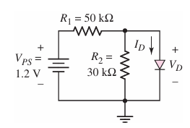

**4)** **(CO2: 11 x 3 = 33)** Consider vi = 10 V, find the state of the diodes, current and voltage of diodes output, vo and current through the resistors:

[Remember to label the diodes as D1, D2,… as required by the circuit. It will aid in readability for yourself when verifying]

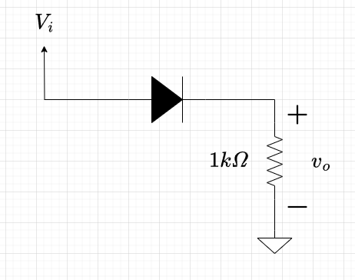 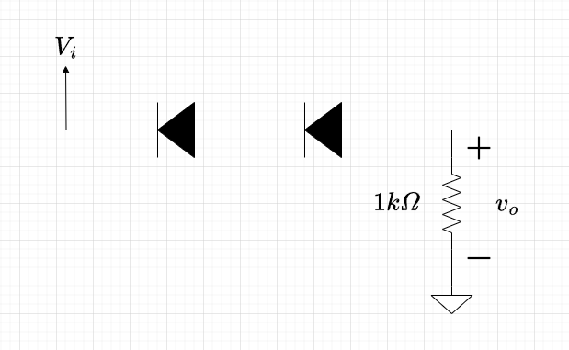 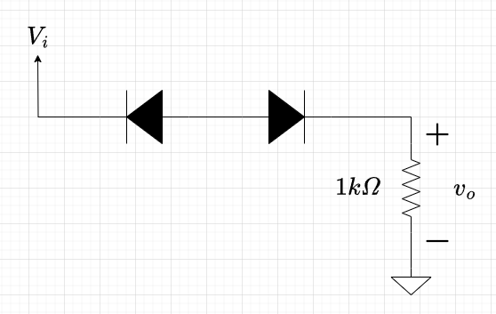

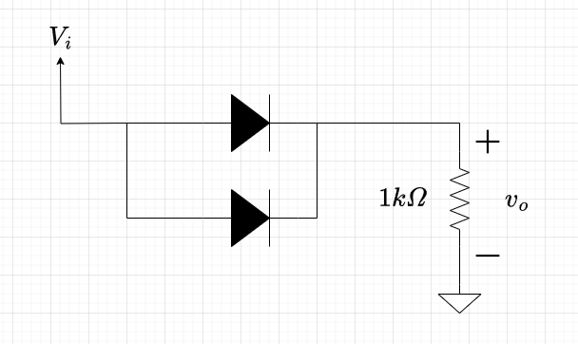 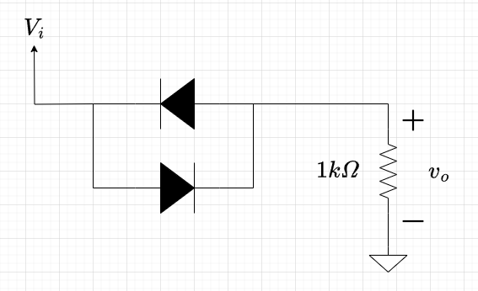 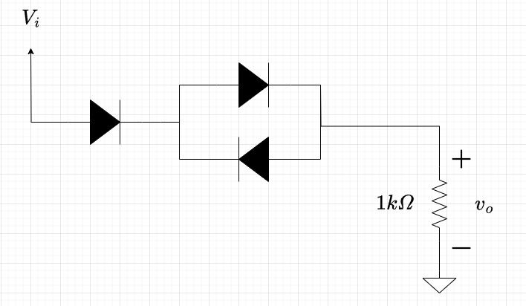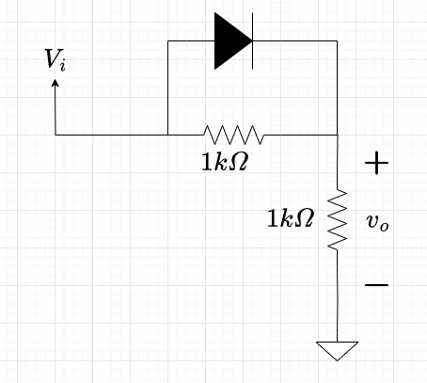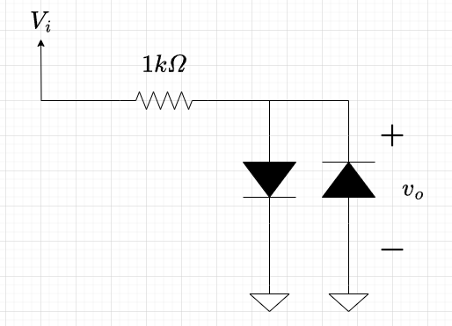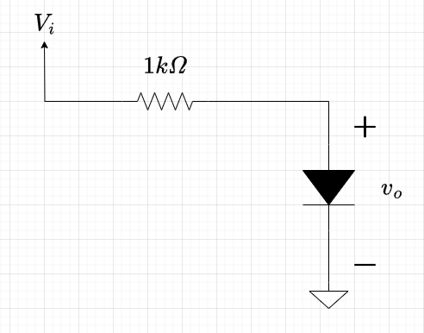

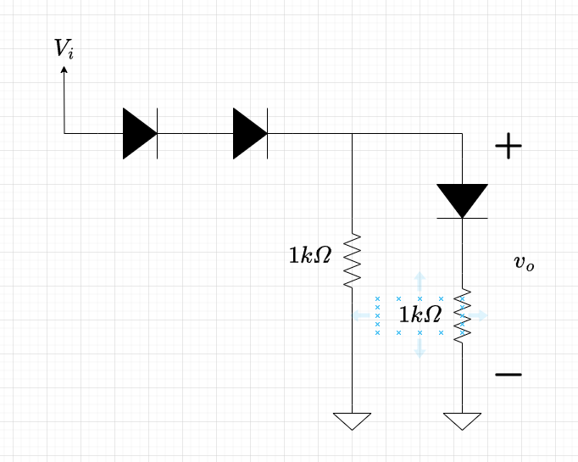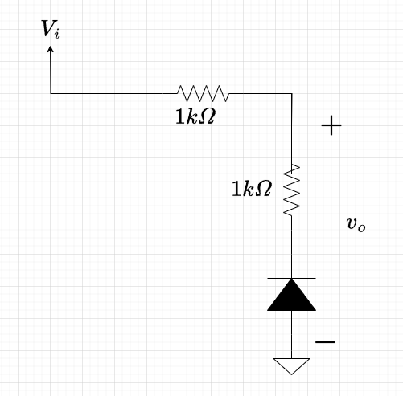

**5) (CO2: 2 x 3 = 6)** Solve the following two diode circuits and find the current through the diodes, the current through the resistors and the output voltage (The lowest node is a -3V source!):

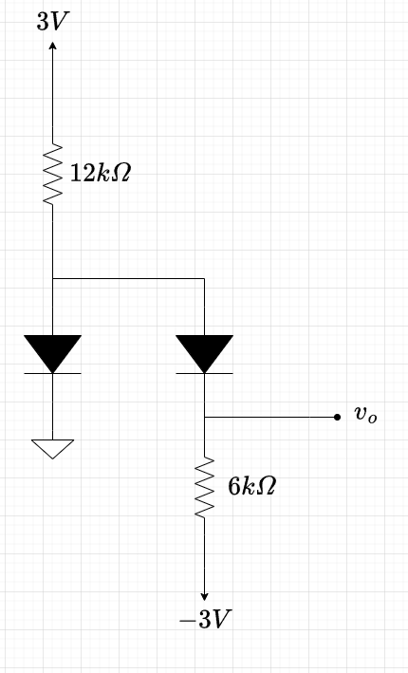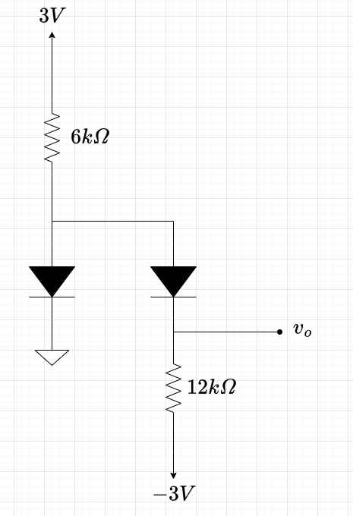

**Ideal Diode model:**

In this approximate (even more of an approximation than the CVD model) model of the diode, we assume once again that it can take TWO states as before in the CVD model: i) ON state and ii) OFF state

1. When the diode is ON (or, forward biased), we say it has the following properties:

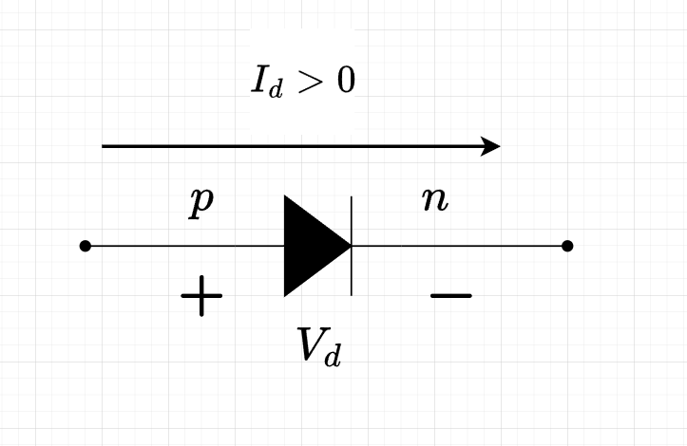

* + The diode current is flowing from the p side to the n side, i.e, the current is positive **(Id > 0)**
  + The terminal voltage drop across the diode is assumed to be 0 V **(Vd = 0 V).** We assume that the diode becomes shorted in ON state

We can replace this diode with an equivalent model as follows:

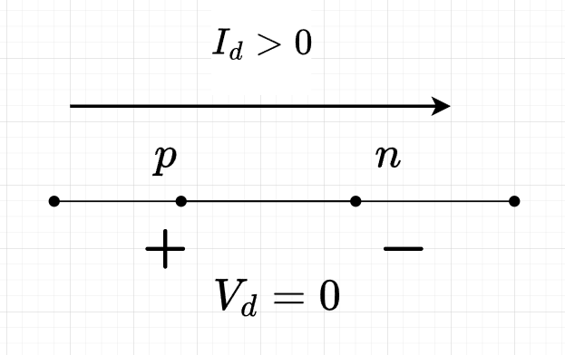

This equivalent diode circuit will be used if any of the following two conditions are fulfilled in a circuit.

Here, the diode will simply behave as if it is a shorted path in the circuit with no voltage drop. It simply lets whatever current the circuit wishes to pass through it!

1. When the diode if OFF (or, reverse biased), we say it has the following properties: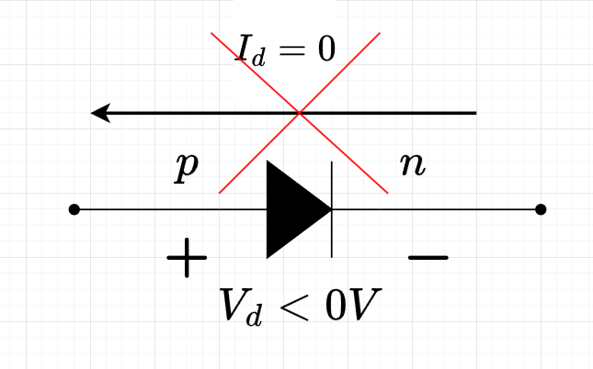
   * The diode current tries to flow from the n side to the p side but it cannot do so, hence the current is zero **(Id = 0)**
   * The voltage across the diode is less than 0 V **(Vd < 0 V)**

We can replace the diode model with an equivalent circuit as follows:

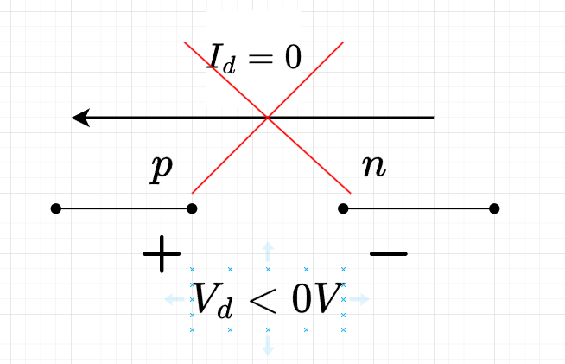

This equivalent circuit will be used if any of the two conditions above are met.

Here, the diode acts as an open circuit component and current cannot flow through it. **(Id = 0)**

Ideal diode model gives us a less accurate analysis of diode circuits but can be a quick way to check the behaviour of diode circuits. One of the places where we use this extensively is understanding diode logic gates and quick analysis of Boolean expression implementation of diode logic circuits.

**Diode Logic Circuits:**

Diode can be used to implement two basic forms of Boolean logic: (i) OR Logic (ii) AND Logic

Diodes cannot be used to implement NOT logic. This is because NOT logic requires a 0V (logical low: 0) input to produce a 5V (logical high: 1) output. This is impossible for diode as it is a passive circuit component, it cannot generate voltage!

**i) OR Logic:**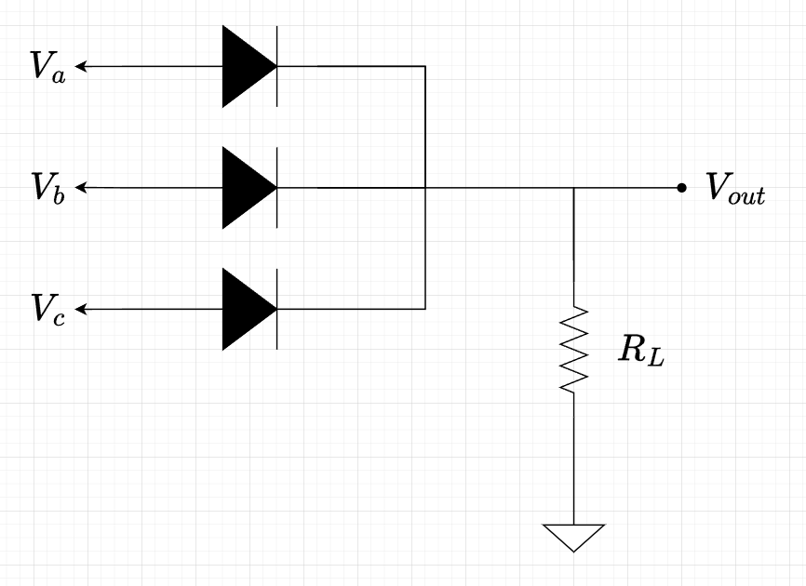

The following circuit below is used to implement OR logic:

Logical 1 -> 5V  
Logical 0 -> 0V

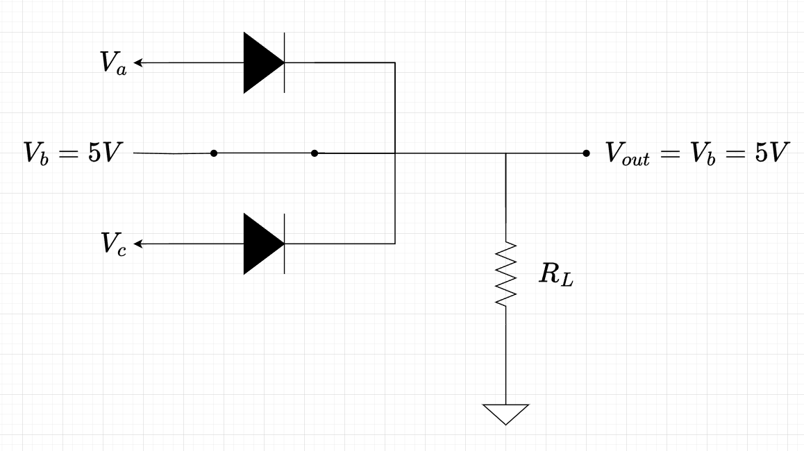

If any of the inputs are 5V, then the diode connected to that input becomes forward biased and ON.

For an ideal diode, ON state means shorted path, thus the input 5V and Vout becomes the same node.

Thus Vout = 5V. The other diodes remain off since Vd < 0V.

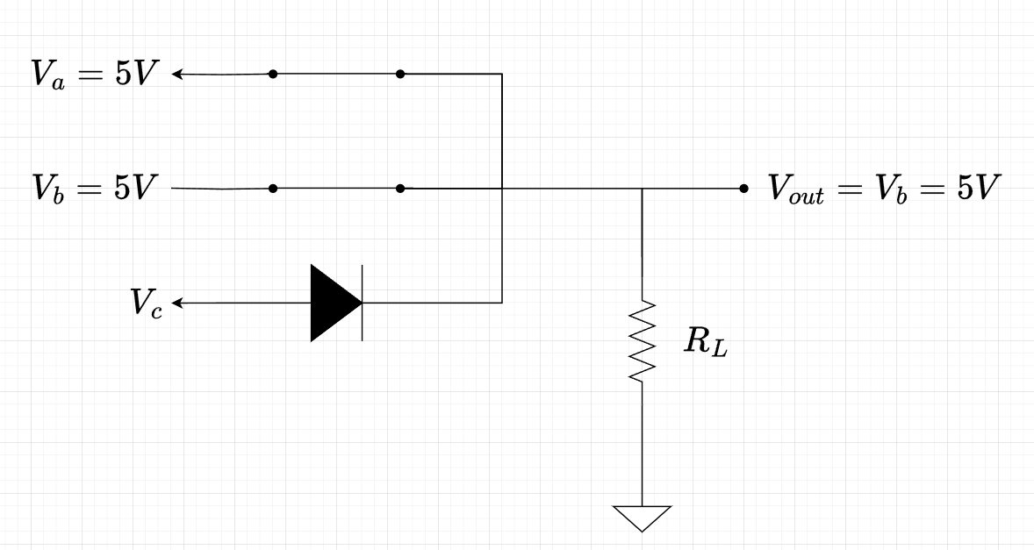

A similar situation happens if any two or all three have high inputs. All three diodes are shorted and Vout = 5V.

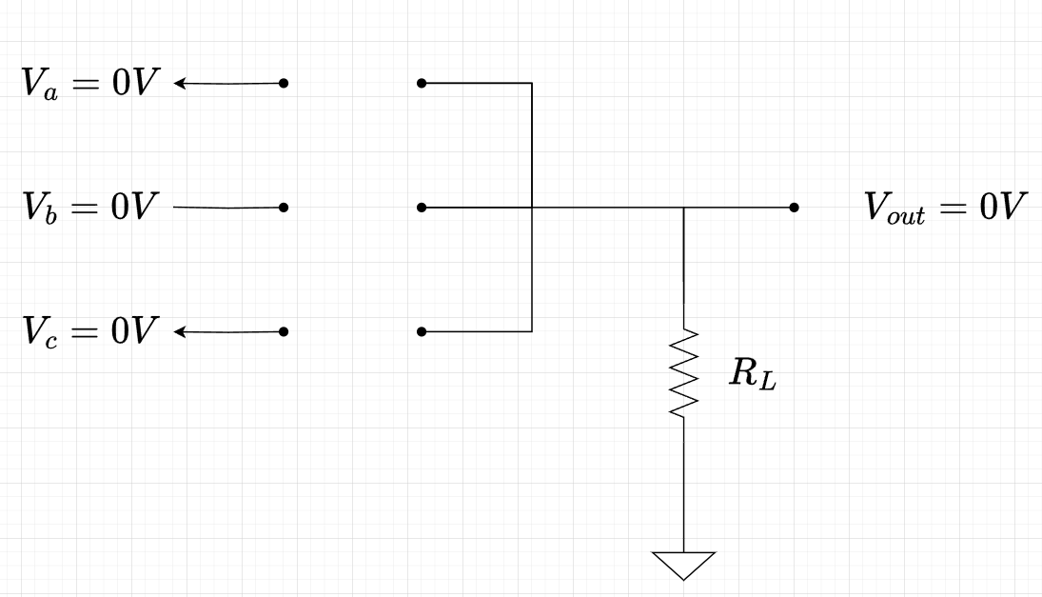

Only if all three inputs are 0V will none of the diodes turn on and thus all three stay OFF.

Thus, no current can flow through the circuit and the voltage drop across the resistance is 0V. This means that the voltage at the two ends of the resistor is the same. So, Vout = 0V.

Thus, we only get 5V in the output if any of the inputs have 5V. If all three of the inputs are 0V, then the output is 0V. This is the characteristic of an OR gate.

Instead of three inputs, we could use as many inputs as we want, and the branches would look similar, instead of three diodes, there would be as diodes as there are inputs connected with a separate branch.

**i) AND Logic:**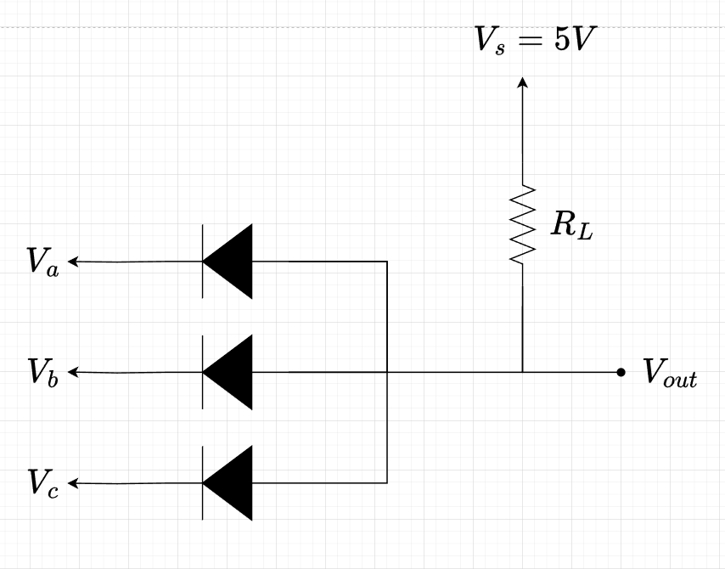

The following circuit below is used to implement AND logic:

Logical 1 -> 5V  
Logical 0 -> 0V

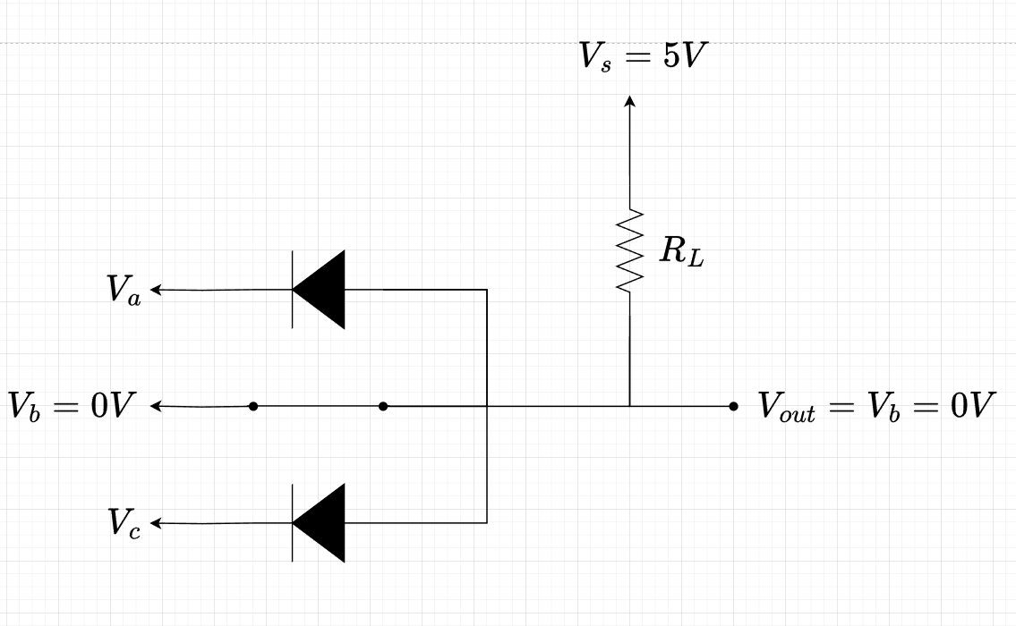

If any of the inputs are 0V, then the diode connected to that input becomes forward biased and ON.

For an ideal diode, ON state means shorted path, thus the input 0V and Vout becomes the same node.

Thus Vout = 0V. The other diodes remain off since Vd < 0V.

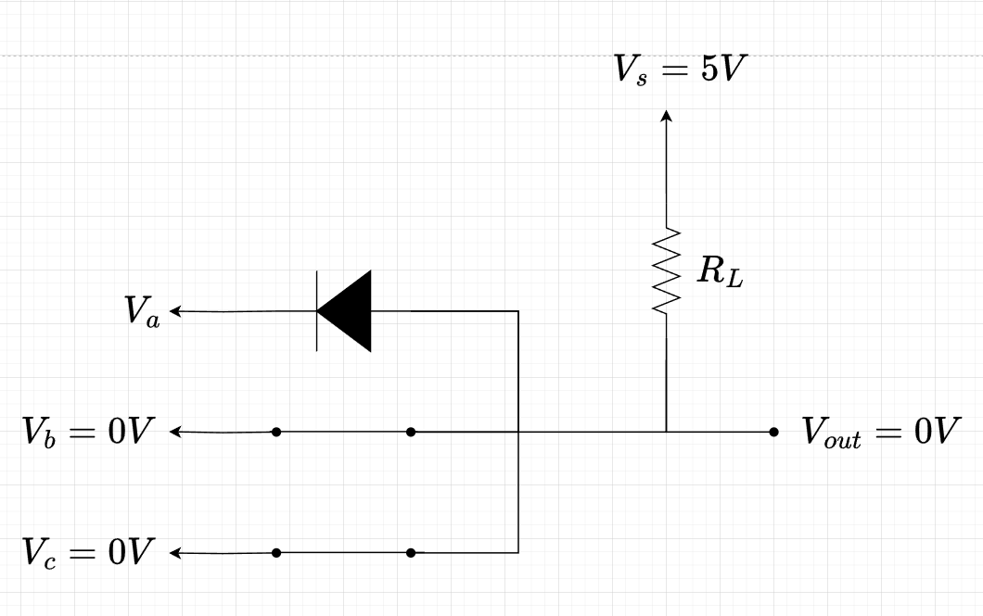

A similar situation happens if any two or all three have high inputs.

All three diodes are shorted and Vout = 5V.

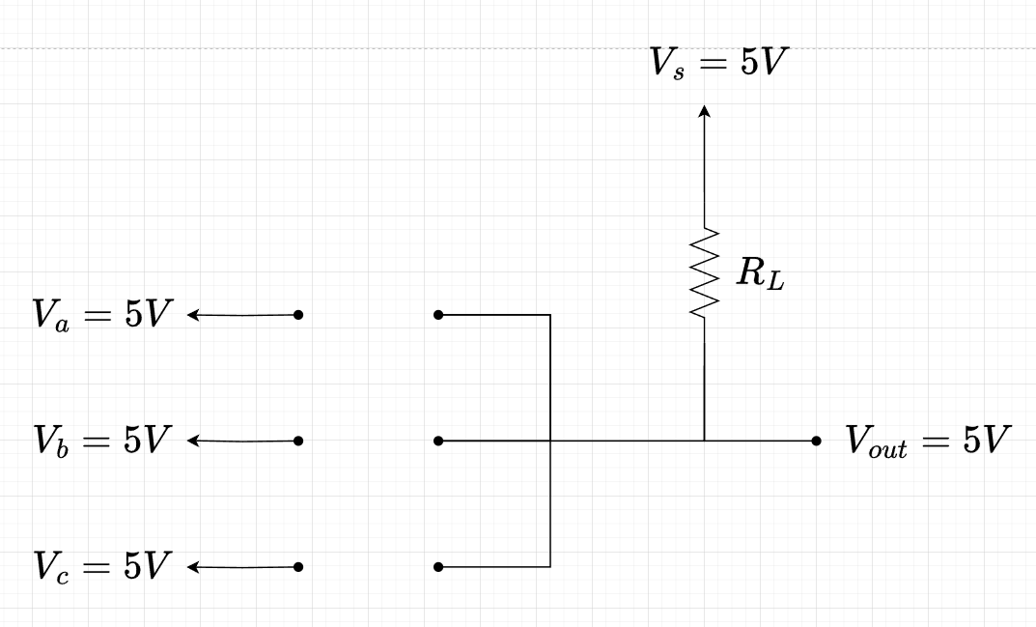

Only if all three inputs are 5V will none of the diodes turn on and thus all three stay OFF.

Thus, no current can flow through the circuit and the voltage drop across the resistance is 0V. This means that the voltage at the two ends of the resistor is the same. So, Vout = 5V.

Thus, we only get 0V in the output if any of the inputs have 0V. If all three of the inputs are 5V, then the output is 5V. This is the characteristic of an AND gate.

Instead of three inputs, we could use as many inputs as we want, and the branches would look similar, instead of three diodes, there would be as diodes as there are inputs connected with a separate branch.

**Implementing Boolean expressions with diode logic gates:**

This is pretty straightforward and should be clear with a single example:

Suppose we would like to implement the logic function, f = AB + CD

We notice that we can produce AB with a diode AND circuit and CD with another diode AND circuit:

Say, E = AB and F = CD. Then f = E + F. so we take the outputs of our two diode circuits and use them as inputs in a diode OR circuit:

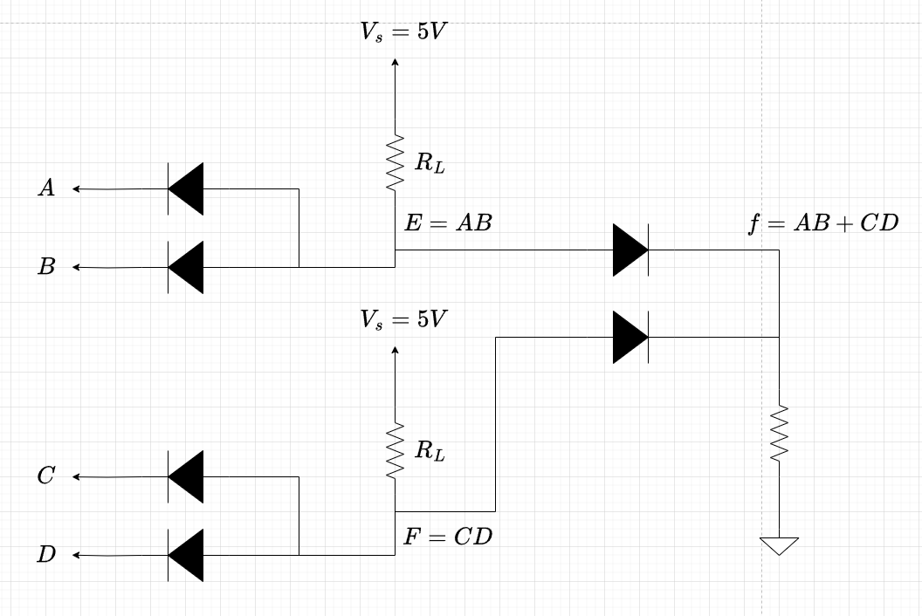

**6) (CO3: 6 x 4 = 24)** Design the diode logic circuits in order to implement the following Boolean expressions:

i) ABCDE

ii) A + B + C + D + E

iii) (ABC + D) E

iv) (A + B + C) DE

v) (A+BC) (D+E)

vi) (AB + BC + CA) (A + B + C) (AD + BE)

Diode logic must be implemented such that the input HIGH and input LOW are the same for each inputs. If they are not the same, the logic circuits implement different functions:

i) The logic OR implements a Vout = max(VA,VB,…) function: gives the output as the maximum of the input voltages.

ii) The logic AND implements a Vout = min(VA, VB,…) function: gives the output as the minimum of the input voltages.

[N.B: the details of analysis are left for the students to go through from the class notes and the slides]

| **7) (CO1, 7 + CO2, 8 = 15)** Consider the following two circuits given below: |  |
| --- | --- |

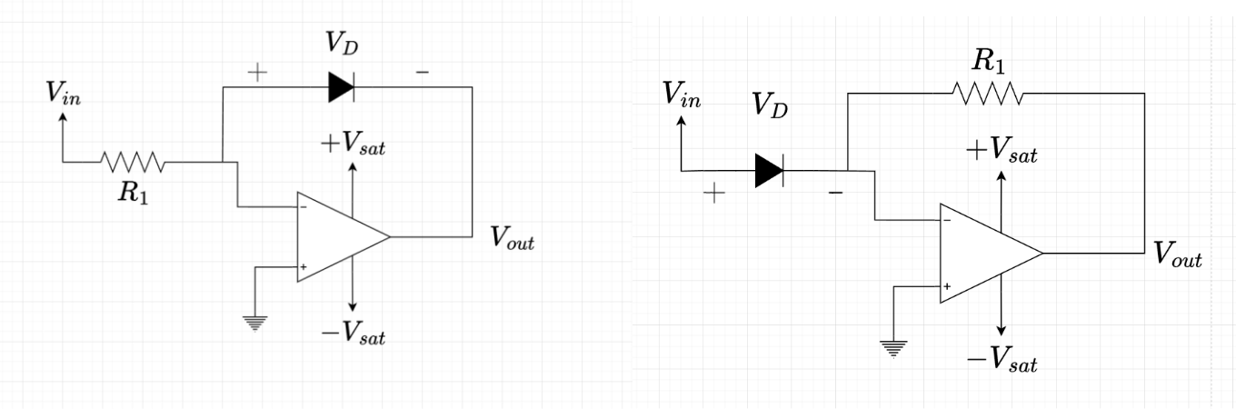

Circuit – 1 Circuit – 2

1. Solve both circuits and find their expressions of **Vout**. What mathematical operations are the two circuits performing on the input voltages? **[CO1] [5]**
2. Find the output values of the two circuits with **Vin = 0.01V, 0.02V, 0.05V** and **0.1V.** Draw a table with two columns, one for output of Circuit-1 and one for Circuit-2, and enter 3 entries for the three input voltages above. **[CO1] [2]**
3. From the table obtained from **(b)**, which of the outputs of the two circuits seem to grow faster? Explain your reasoning from the expressions obtained in **(a)** and tabular values from **(b)**. **[CO2] [3]**
4. Now connect the output of the first circuit with the input of the second circuit. Draw the connected circuit and find the output voltage expression from an arbitrary input, Vin. **[CO2] [5]**

[N.B: in order to solve such an op amp circuit with diodes connected, use the diode Schockley equation as given below and apply KCL to the inverting terminal of the op amp. The diode current plus the current through the feedback resistor will equal zero. Then simply solve for the output voltage]

Given that, **Is = 10-9 A, R1 = 10 MΩ and VT = 0.0259 V**. Also, the diode shockley equation that relates the current through it to the voltage across the diode is given by: **ID = Is*exp[(VD/VT)-1]** where **exp()** is the exponential function.

